Charities

Sue Ryder
Klokanek

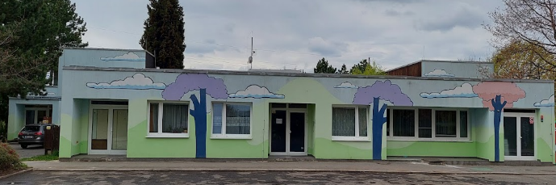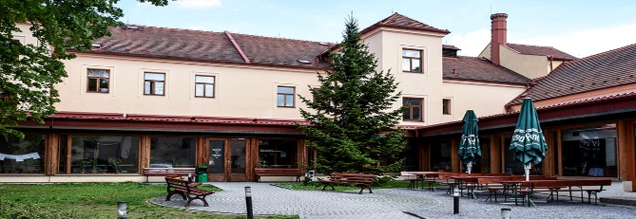
Klokanek
Klokanek is a facility for children that require immediate help. Its founder is the Endangered Children Fund z.s.
Klokanek is authorized to provide social and legal protection, which is granted by the City Hall of Prague.
Klokanek provides temporary family-type care to children aged 0 – 18 years, all over the country, who cannot stay with their family due to improper care which Klokanek in turn offers to ensure basic life needs for these children.
Cooperation between Klokanek and PBIS
- We have actively participated in helping these children see the magic of the holiday season by putting together Christmas gifts for specific children at Klokanek.
- We have also contributed to providing necessities for enhancing the children's educational learning (educational toys, school supplies,…)
- In the past few years, we also helped Klokanek by purchasing an annual transport card, detergents and other urgent needs

- Thanks to the great support of PBIS parents working for HP company, Klokanek also received a printer
Goals for 2023/2024
- Invite Klokanek representative to PBIS in order to inform students about their activities
- organize Christmas gifts for Klokanek children in December 2023
- organize a fundraising in order to buy urgent supplies, needs (to be discussed with Klokanek)/ during 2023/2024
- support Klokanek by organizing some events, e.g. International Children’s Day

Sue Ryder
Sue Ryder is czech non-for profit organization that helps to elderly and their families when the circumstances of aging may seem to be out of control.
Sue Ryder is czech non-for profit organization that helps to cultivate the social and health system in the Czech Republic.

Sue Ryder has also 8 charity shops where you can donate or buy items, with the proceeds funding care for seniors.
Their services:
- personal assistance
- residental care: holistic and individualized care
- palliative care

Cooperation between Sue Ryder and PBIS
- PBIS community helped Sue Ryder to buy an adjustable medical bed for seniors

- PBIS Friends donated financial gifts to Sue Ryder to support their activities

- We also organized a Christmas bake sale where we sold the Sue Ryder postcards to raise money for them

- Sue Ryder invites us to their Open Days, concerts and exhibitions

Goals for 2023/2024

- Invite Sue Ryder representative to school to inform students about their activities
- Organize a fundraising in order to help Sue Ryder (financial gift or special needs for seniors)
- Organize a visit of PBIS students to Sue Ryder in Michle (e.g. musical concert of PBIS students for seniors, art exhibitions/auction of PBIS students …)

