TICK – BORNE ILLNESS

European tick-borne encephalitis and Lyme disease-borreliosis have become more common and widespread since the 1970`s because of the climate and environmental changes.
These areas are widely scattered from the east coast of Sweden, rural areas of Poland, The Czech Republic, Slovakia, Austria, Bavaria, Hungary and the former Soviet Republics.
The peak incidence is from April to October depending on weather conditions.

Incidence of TBE in the Czech Republic and Europe

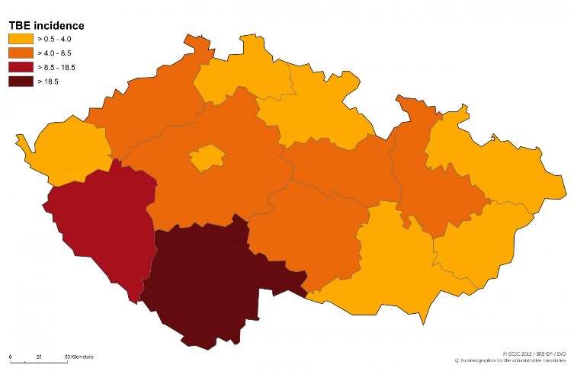

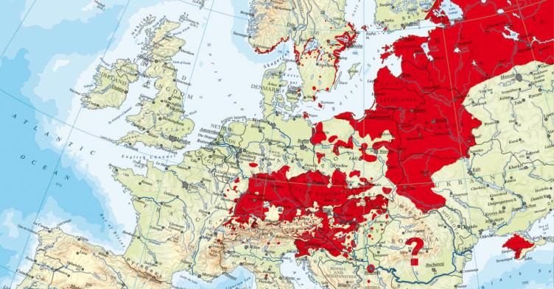

TICK – BORNE ENCEPHALITIS
Tick borne encephalitis is a viral infection that attacks the central nervous system. Ticks are important in the transmission. Humans may also acquire infection by consumption of infected unpasteurized (or not properly brought to boiling) milk or dairy products though this is rare.
The incubation period is usually from 1 to 3 weeks, but may vary.
It typically begins as a flu-like illness, including fever and headache. This is the first stage followed by the second stage that develops encephalitis, meningitis, encephalomyelitis and paresis.
Adults older than 40, usually develop more serious symptoms than children.
There are no proven treatments for tick-borne encephalitis. Gamma globulin and corticosteroids are sometimes used, but the effectiveness is unknown.

LYME DISEASE
Lyme disease is an illness caused by the bacteria, Borrellia burgdorferi. Doctors struggle to diagnose Lyme disease accurately because it is a complex illness.

The First Stage of disease can occur at any time from 3 to 30 days after being bitten by an infected tick. The first signs are erythema around the place where a tick bite or an atypical rash over the body.
Don’t hesitate to go to see your GP or pediatrician. Oral antibiotics should be given! (But using antibiotics for tick bites should be avoided).
Treatment during early stages can cure the infection and prevent complications.

The Second Stage develops if Stage 1 has not been treated (days or weeks after infection). The main symptoms are: pain in the joints, facial palsy, heart disorders, meningitis, conjunctivitis, mild hepatitis, fatigue and so on.

The Third Stage - months to years later.
Symptoms: prolonged arthritis, chronic encephalomyelitis, severe fatigue and so on.

HOW TO PREVENT TICK-BORNE ILLNESS

Some of you asked us for detailed information about tick-borne illnesses prevention. We hope you will find the enclosed information helpful when you plan to spend some time in the countryside, forest or park.

European tick-borne encephalitis and Lyme disease-borreliosis have become more common and widespread since the 1970`s because of the climate and environment changes.
Widely scattered areas are The Czech Republic, Slovakia, Poland, Austria, Bavaria, Hungary and the former Soviet Republics.
The peak incidence is from May to September.

TICK – BORNE ENCEPHALITIS
Tick borne encephalitis is a viral infection of the central nervous system. Ticks are important in the transmission. Adults usually develop more severe symptoms than children.

LYME DISEASE
Lyme disease is an illness caused by the bacteria, Borrelia burgdorferi. Lyme disease might struggle to be accurately diagnosed because it is a complex illness. Treatment is effective only in the first stage!

Recommendation:

- Be aware that areas at high-risk for ticks include vegetated, overgrown areas, forests and parks.
- Wear light clothes with long sleeves, long trousers (tuck pant legs into socks), and a hat. Wearing Wellington boots in totally forested areas are highly recommended. Use a light blanket to sit down on grass so crawling ticks can be visible.
- Use repellents or bracelets according to instructions.
- Check your/children’s body after being in a possibly tick-infected area. Inspection reduces the risk of disease transmission. After crawling on a potential host, a tick may take up to a day to attach.
- If you find a tick, don’t panic. A low percentage of ticks carry disease.
- To remove a tick use latex disposable gloves and tweezers or “hooks” (see below). Grasp the tick as near to the skin as possible. Move with it gently from one side to another (don’t twist, don’t squeeze).
- Disinfect the bite area with antiseptic (Jodisol or Betadine for example) and wash your hands. The removed tick should be flushed in a toilet, not squeezed.
- If you tear the tick and the mouth part remains in the skin, go and see a doctor as soon as possible.
- Don’t use cream or oil to remove the tick. This can cause tick’s “vomiting” into the skin bite and increase the likelihood of disease transmission.
Use the same procedure with your pets (dogs, cats)

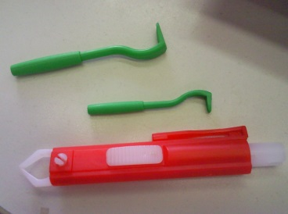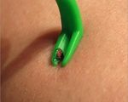

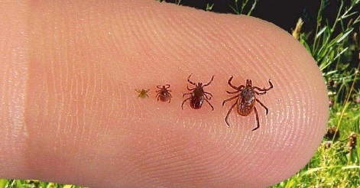

Tick Activity Forecast Service

This service is provided by the Czech Hydrological Institute from April to October. The aim is to identify the risk of tick infestation.
If you are interested in monitoring tick activity and are planning your outdoor family activities according to this risk, please see this websites (unfortunately it is only in Czech):

http://www.chmi.cz/portal/dt?portal_lang=cs&menu=JSPTabContainer/P9_0_Predpovedi/P9_1_Pocasi/P9_1_1_Cesko/P9_1_1_6_Klistata&last=false

You will see the table with dates and levels of the ticks’ activity.
The forecast is issued every Monday and Thursday. It identifies different levels of ticks’ activity. The levels range from number 1 to 10.

Level 1 - 2 almost no risk
Level 3 – 4 little risk
Level 5 – 6 some risk
Level 7 – 8 great risk
Level 9- 10 highest risks

Recommendation
Level 1 - 2: choose light coloured clothes for outdoor activities and check your body twice a day.
Level 3 – 6: the same as above and use repellent.
Level 7 – 8: follow the above recommendations and avoid sitting and lying at streams, forests and meadows.
Level 9 – 10: use repellent, check your body twice a day and avoid parks, forests etc. Walk only on solid roads.
Ticks can be found in parks, forests and gardens. They have specific needs for wet environments and therefore they are not usually found in sunny and dry places. Neither are they to be found in boggy places.

VACCINATION

A Vaccination against Lyme disease does not exist yet.

The Vaccination against European tick borne encephalitis is considered to be the most effective means of preventing TBE. The vaccination consists of three injections.
The second vaccine is given 1-3 months after the first and the third is given 5-12 months after second.
It is recommended to have booster doses every three to five years.
The vaccination series should ideally be started in winter. Effective immunity will then be present at the start of the tick season.
Remember your GP is always a good source of further information.

If you have any further questions, please do not hesitate to contact Ms. Eva Cyrusová
(tel. 737 916 231).

